C4 Lab si3g19

Design And Test Of Finite State Machines

3.1 Functional Testing

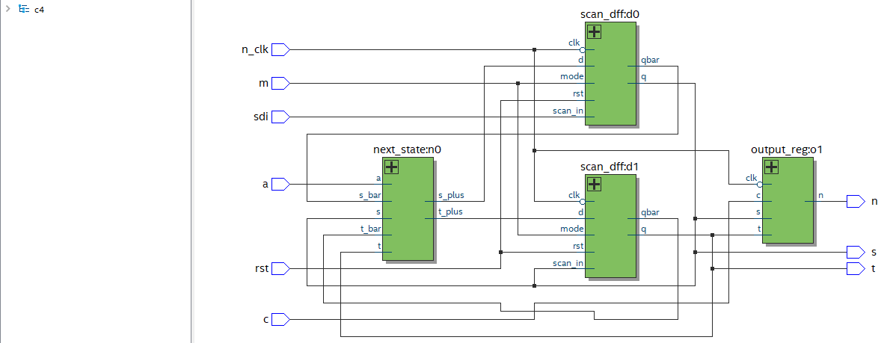

* Do your test sequences verify that the circuit has been implemented correctly?

FPGA behaviour observed meets the expected

Behaviour matched modelsim simulation and the circuit was implemented correctly using quartus

3.2 Fault Detection and Diagnosis

(a) Apply a stuck-at-1 fault and step through the test sequence

Stuck at 1:

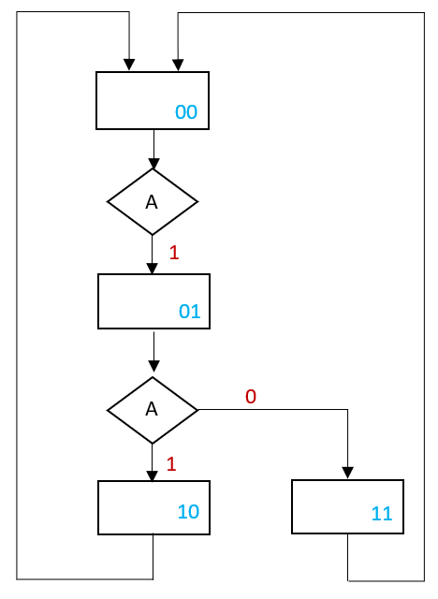

Doesn’t remain in the 10 state when clocked

The fault was detected, can deduce fault location

(b) Apply a stuck-at-0 fault and step through the test sequence.

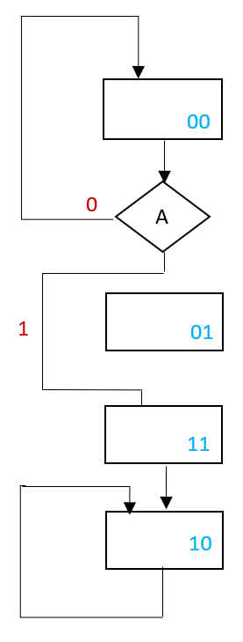

Gets stuck in 10 state until manually reset

The fault is detected

Can deduce fault point.

3.3 Sequential Output Logic

* With both faults disabled, verify that your previous test sequence finds no fault.

verified

Apply the stuck-at-1 fault

* Is the fault detected? If so, is it possible to diagnose the fault location?

Sequence for stuck at 1:

A=0, rst, a= 1, 1, 1;

Fault is detected by state, as cant go back to S(1) T(0)

Sequence for stuck at 0:

A=0, rst, a= 1, 1;

Fault is detected by state, state skips S(0) T(1)

* How effective is transition verification as a basis for testing an FSM?

How can you verify transitions from redundant states, and what is the relative cost of doing this?

Fault will be detected

Cannot diagnose location of fault

* How easy is it to detect and diagnose faults in non-scan-path FSMs with and without output logic?

Its difficult to diagnose fault in non-scan path FMSs as we can’t set and observe our present state

Can only go through the state through input.

3.4 Scan Design

C4:

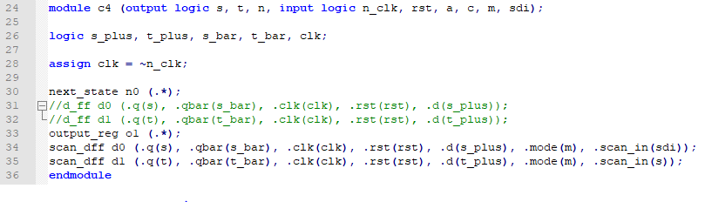

Test_c4:

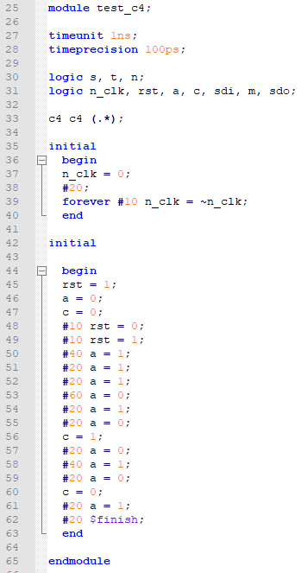

Scan_diff:

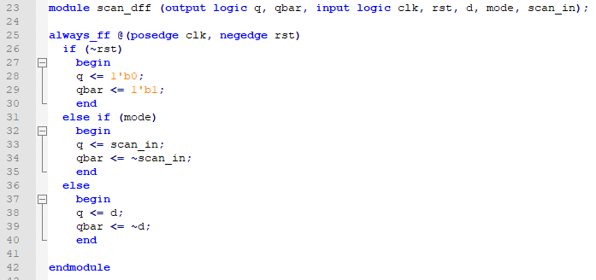

Waveform:

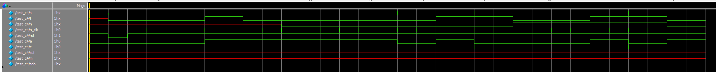

Fault equation: y= (t*s) + $\overline{A}$

Correct equation: y= (s*t) + $\overline{T}$